Pandas is defined as an open-source library that provides high-performance data manipulation in Python.

The name of Pandas is derived from the word **Panel Data**, which means **an Econometrics from Multidimensional data**. It is used for data analysis in Python and developed by **Wes McKinney** in **2008**.

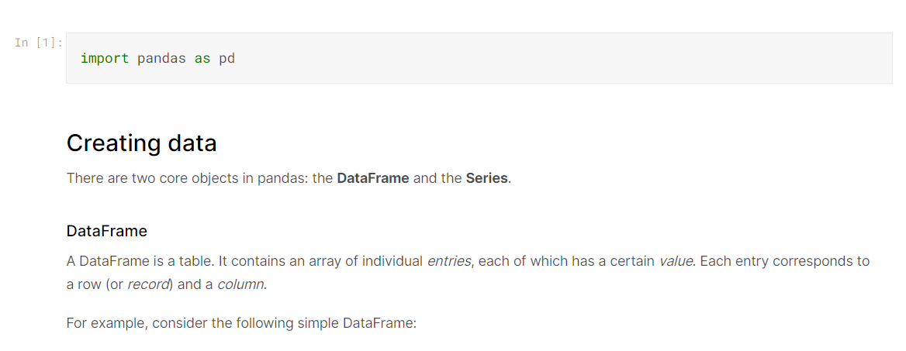

Standard Way of creating a Dataframe:

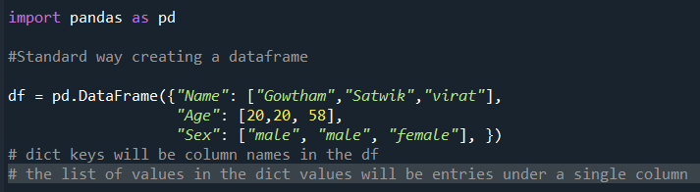

Output:

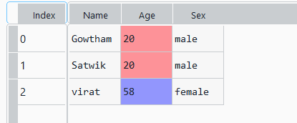

The list of row labels used in a DataFrame is known as an **Index**. By default row labels are taken from (0,1,2,3,4,5…..).

We can assign values to it by using an index parameter in our constructor:

Before using index parameter:

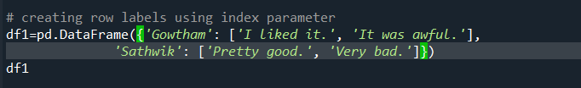

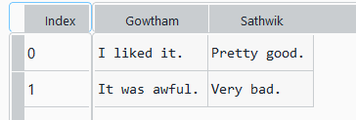

After using index parameter to name row labels:

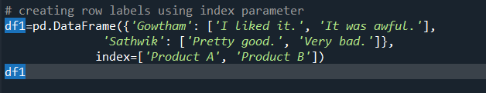

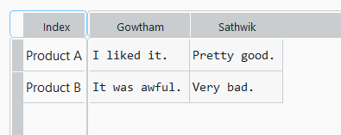

Series

A Series, by contrast, is a sequence of data values. If a DataFrame is a table, a Series is a list. And in fact you can create one with nothing more than a list:

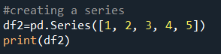

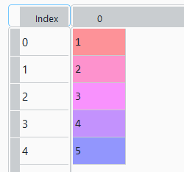

A Series is, in essence, a single column of a DataFrame. So you can assign row labels to the Series the same way as before, using an index parameter. However, a Series does not have a column name, it only has one overall name:

# using index parameter and name paramter to name series



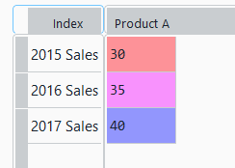

Reading data files

Being able to create a DataFrame or Series by hand is handy. But, most of the time, we won't actually be creating our own data by hand. Instead, we'll be working with data that already exists.

Data can be stored in any of a number of different forms and formats. By far the most basic of these is the humble CSV file. When you open a CSV file you get something that looks like this:

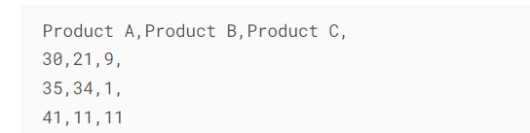

We'll use the pd.read_csv() function to read the data into a DataFrame.



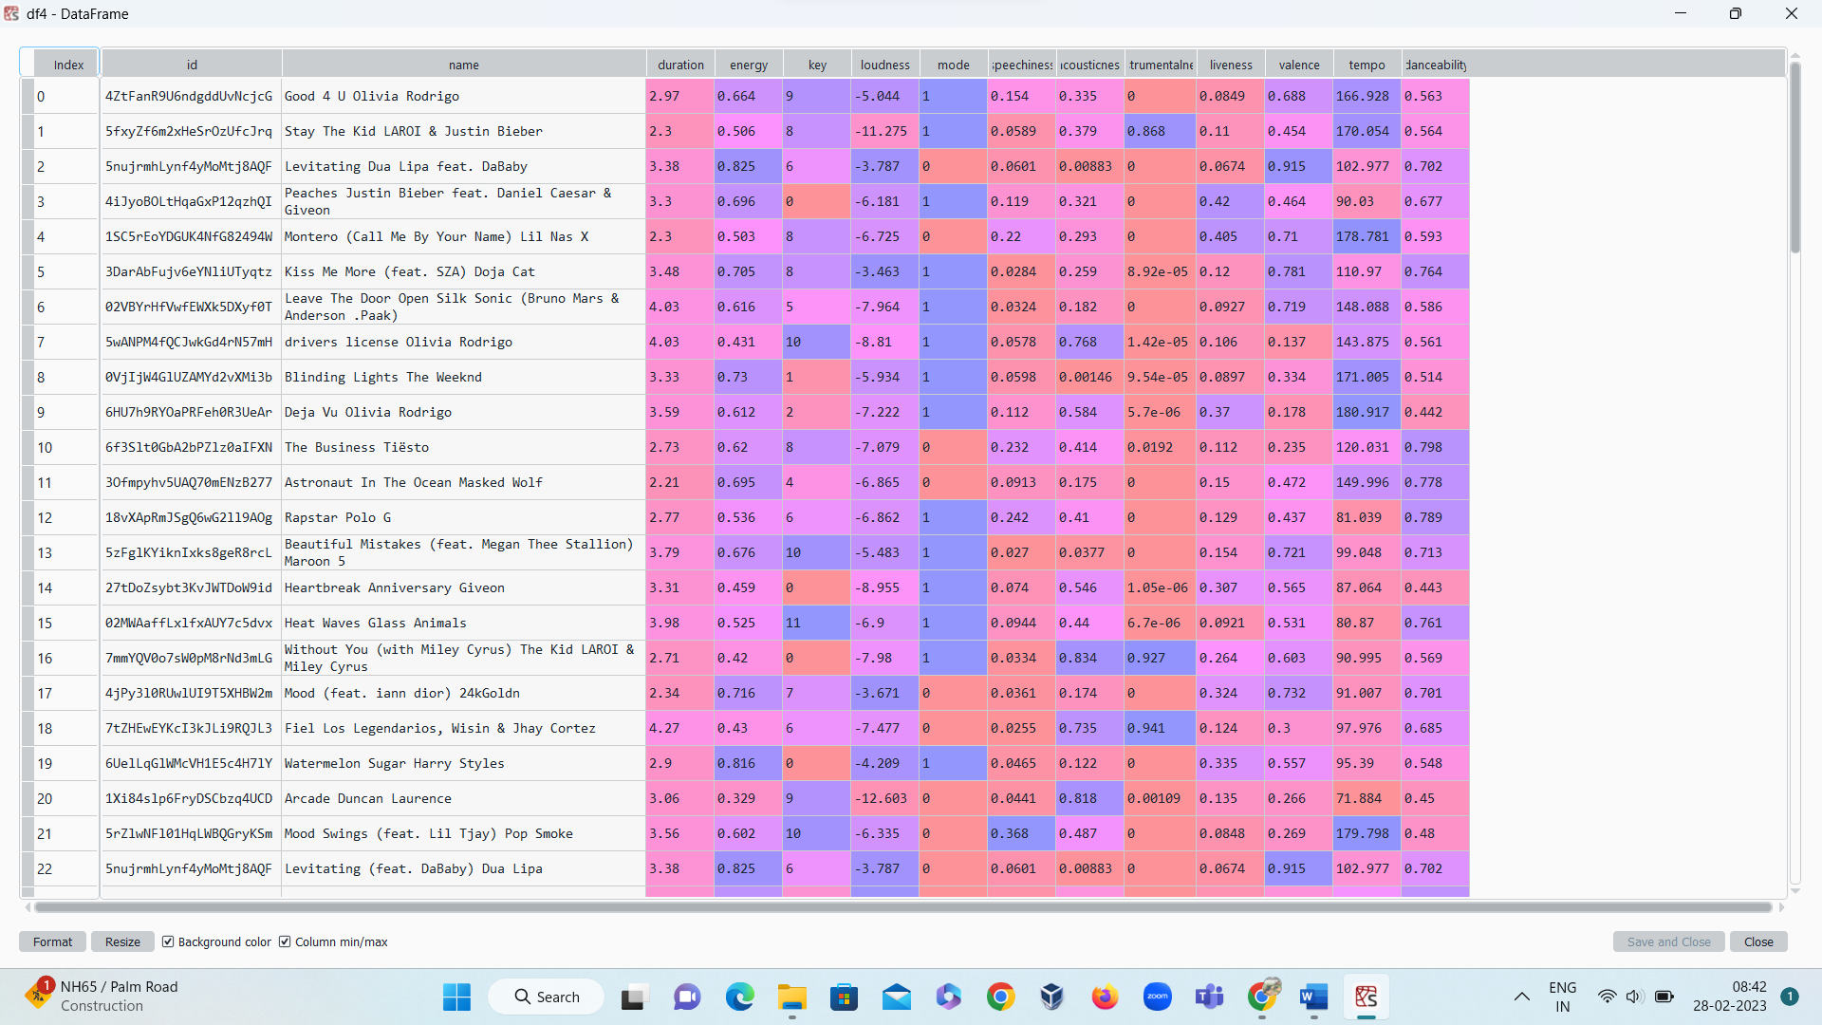

Index_col parameter inside read_csv function:



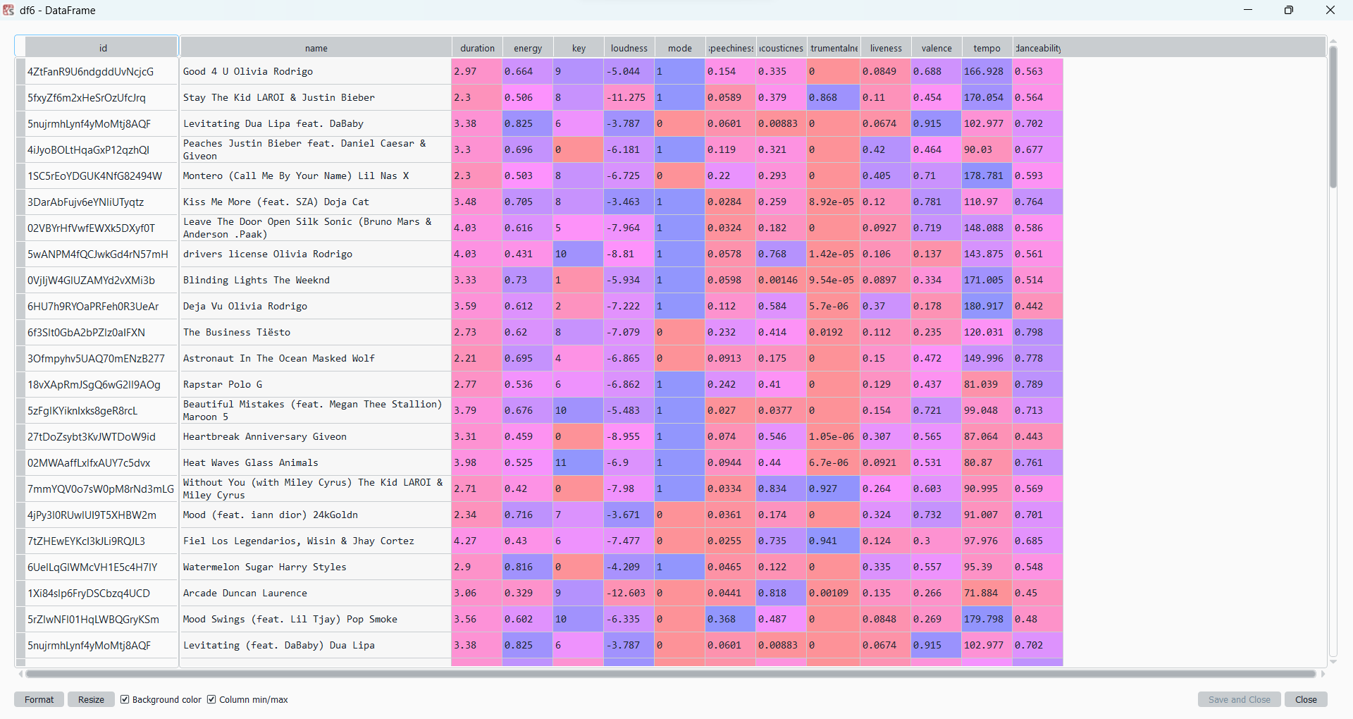

Excel of top 100 songs: <https://www.kaggle.com/datasets/amaanansari09/top-100-songs>



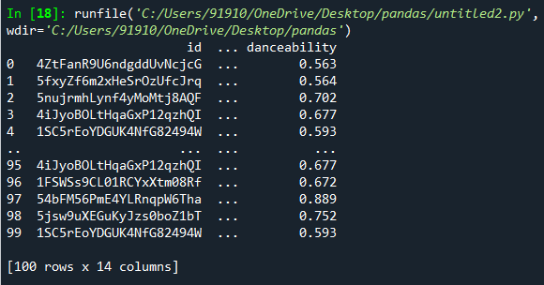

We can examine the contents of the resultant DataFrame using the head() command, which grabs the first five rows:



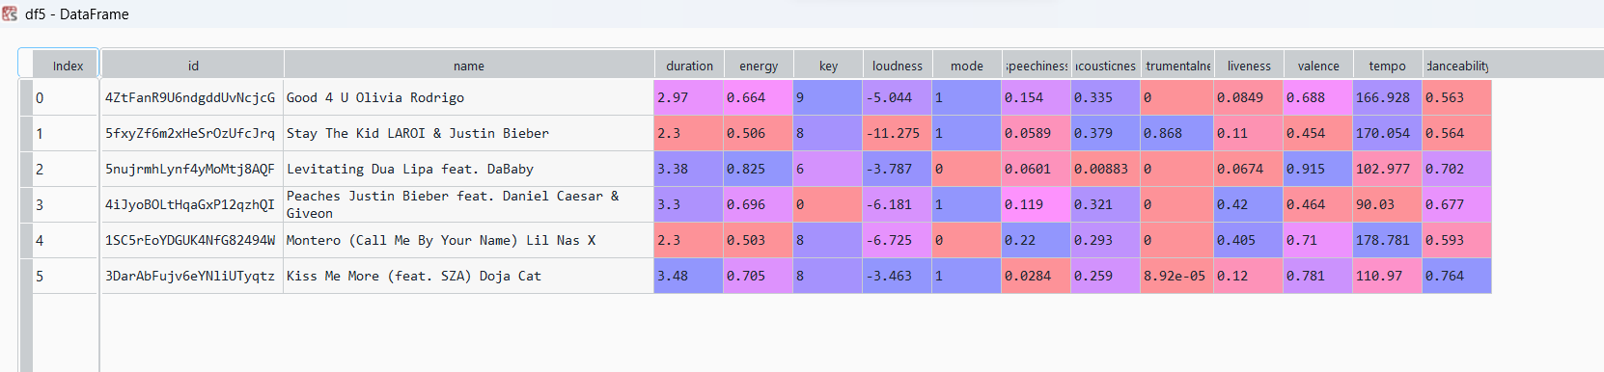

Native Accessors:

Accessing values of a column:

1)attribute method

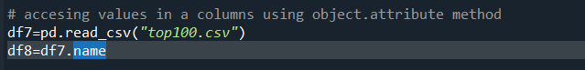

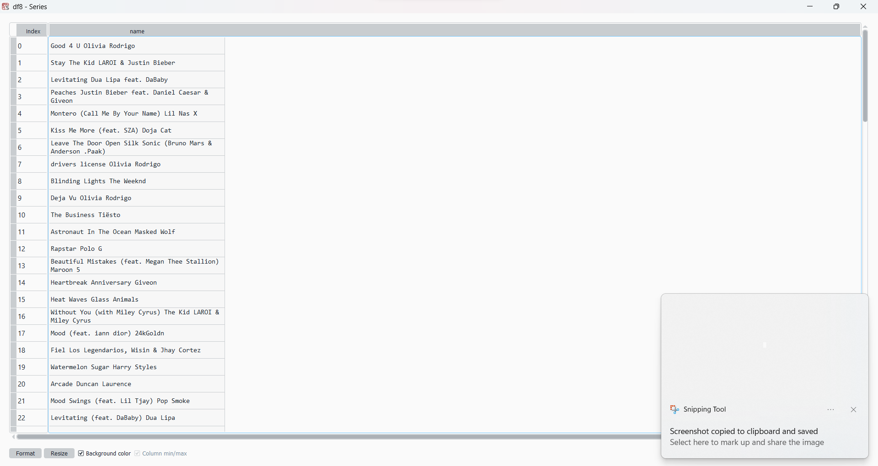

2)indexing operator

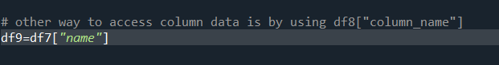



The second method has slight advantage over the other the first. Like when we try accesing the column with name (F name ) we cannot do it with attribute

Accesing single data entry:





Accessors in pandas:

1)iloc 2)loc

Indexing in Pandas:

The first is **index-based selection**: selecting data based on its numerical position in the data. iloc follows this paradigm.

To select the first row of data in a DataFrame, we use the following:



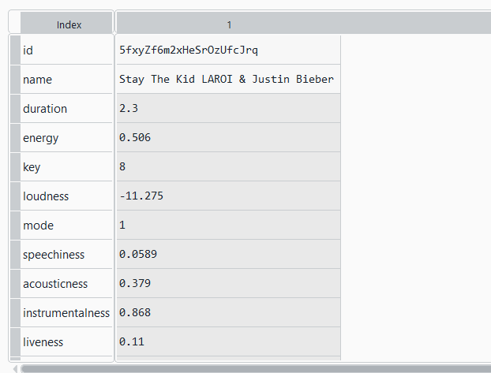

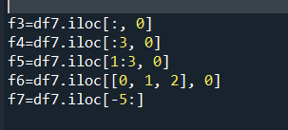

### **Label-based selection**

The second paradigm for attribute selection is the one followed by the loc operator: **label-based selection**. In this paradigm, it's the data index value, not its position, which matters.

For example, to get the first entry in reviews, we would now do the following:



Output:



iloc is conceptually simpler than loc because it ignores the dataset's indices. When we use iloc we treat the dataset like a big matrix (a list of lists), one that we have to index into by position. loc, by contrast, uses the information in the indices to do its work. Since your dataset usually has meaningful indices, it's usually easier to do things using loc instead.

# Manipulating the index

Label-based selection derives its power from the labels in the index. Critically, the index we use is not immutable. We can manipulate the index in any way we see fit.

The set_index() method can be used to do the job. Here is what happens when we set_index to the title field:



This is useful if you can come up with an index for the dataset which is better than the current one.

# Conditional selection

So far we've been indexing various strides of data, using structural properties of the DataFrame itself. To do *interesting* things with the data, however, we often need to ask questions based on conditions.

For example, suppose that we're interested specifically in song duration less than 5 min:

We can start by checking if each song is less than 3 mins:



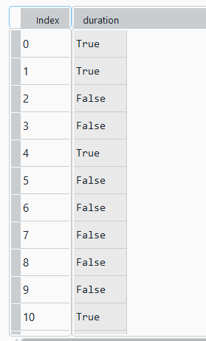

This operation produced a Series of True/False booleans based on the duration of each record. This result can then be used inside of loc to select the relevant data:

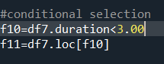

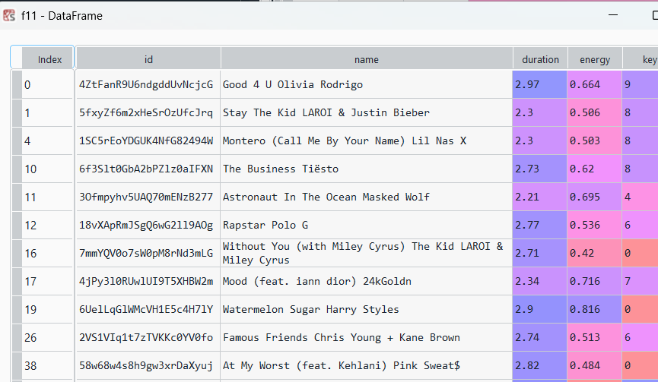

#mutiple conditions:

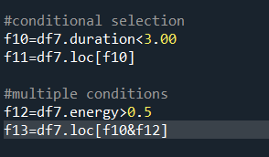

**Output:**

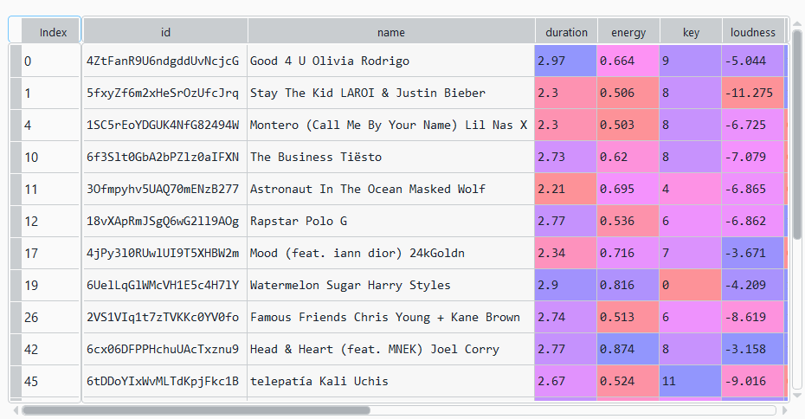

Pandas comes with a few built-in conditional selectors.

1)isin.

The first is isin. isin is lets you select data whose value "is in" a list of values.  For example, here's how we can use it to select wines only from Italy or France:

reviews.loc[reviews.country.isin(['Italy', 'France'])]

2)isnull:The second is isnull (and its companion notnull). These methods let you highlight values which are (or are not) empty (NaN). For example, to filter out wines lacking a price tag in the dataset, here's what we would do:

reviews.loc[reviews.price.notnull()]

# Assigning data

Going the other way, assigning data to a DataFrame is easy. You can assign either a constant value:

Or with an iterable of values:

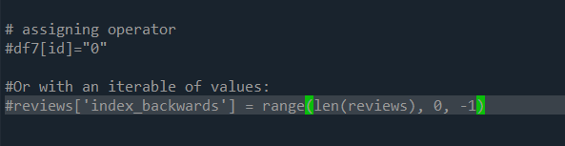

# Summary functions

Pandas provides many simple "summary functions" (not an official name) which restructure the data in some useful way. For example, consider the describe() method:

 It is type-aware, meaning that its output changes based on the data type of the input.

1)Describe function:

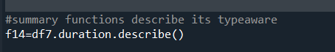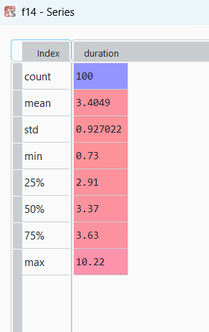

Here id is in string format



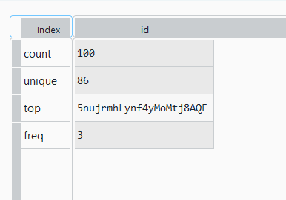

2) Mean function:





2)unique function:



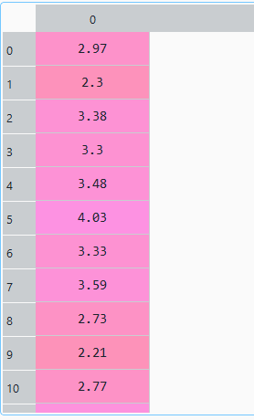

3)value_counts()



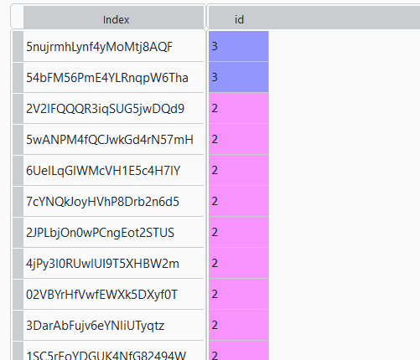

# Maps

A **map** is a term, borrowed from mathematics, for a function that takes one set of values and "maps" them to another set of values. In data science we often have a need for creating new representations from existing data, or for transforming data from the format it is in now to the format that we want it to be in later.

There are two mapping methods that you will use often.

1)Map



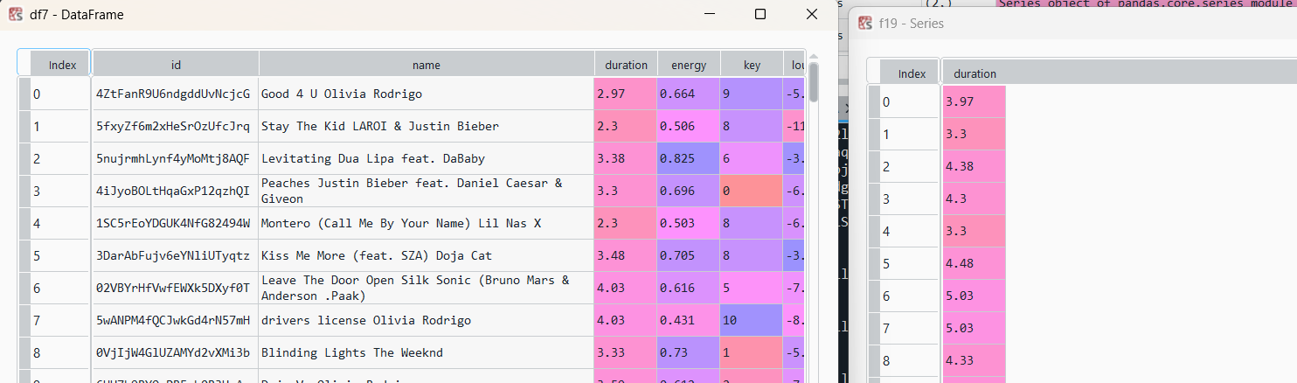

The function you pass to map() should expect a single value from the Series (a point value, in the above example), and return a transformed version of that value. map() returns a new Series where all the values have been transformed by your function.

2)Apply

[apply()](https://pandas.pydata.org/pandas-docs/stable/generated/pandas.DataFrame.apply.html) is the equivalent method if we want to transform a whole DataFrame by calling a custom method on each row.